Utshab Kumar Ghosh

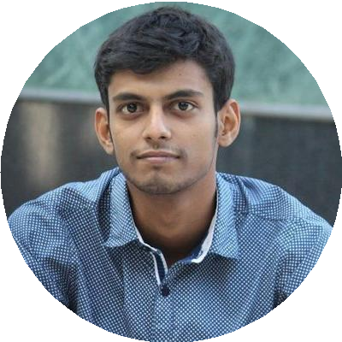

I have been working with Machine Learning and Data Science for about 3 years. My main motto is to collaborate in the field of Data Science, Machine Learning, and Deep Learning, as an ML Engineer or a Data Scientist. With the knowledge of back-end development along with ML competitions in Kaggle, I want to gather experience and knowledge from a based environment and to make some contributions to humankind.



[kumarutshab@gmail.com](mailto:kumarutshab@gmail.com)

+880 1701-067 875 |

Rajshahi, Bangladesh

[utshabkg.github.io](https://utshabkg.github.io/)

[linkedin.com/in/utshabkg](https://linkedin.com/in/utshabkg)

[@utshabkg](https://twitter.com/utshabkg)h

[github.com/utshabkg](https://github.com/utshabkg)

[medium.com/@utshabkg](https://medium.com/%40utshabkg)

# EDUCATION

## B.Sc. in Computer Science & Engineering

### Rajshahi University of Engineering & Technology

01/2017 - Present, Rajshahi, Bangladesh

## Higher Secondary School Certiﬁcate

### Saint Joseph Higher Secondary School

04/2014 - 04/2016, Dhaka, Bangladesh

##### G.P.A. 5 (Based on 5)

**Secondary School Certiﬁcate**

Ideal School & College

01/2009 - 03/2014, Dhaka, Bangladesh

##### G.P.A. 5 (Based on 5)

**WORK EXPERIENCE**

**AI Research Assistant**

MyMedicalHUB

10/2020 - Present, FLorida, USA

Achievements/Tasks

##### Gait Analysis Project

##### Sports Video and Image Analysis Project

##### Worked with AWS, Apache Server, REST API

Contact: <http://mymedicalhub.com/>

## Smart Book Writer

### 10 Minute School

12/2017 - 01/2019, Dhaka, Bangladesh

Contact: https://10minuteschool.com/

**ORGANIZATIONS**

## Co-Founder

### Code Studio

A software startup that builds Mobile and Web Application

**Asst. Publication Secretary**

*RUET Career Forum*

03/2018 - 12/2019

***Vice President (Admin)***

*Onuronon, RUET Cultural Club*

**Founder & Keyboardist**

Plectrum Band

# SKILLS

Machine Learning

Data Science

Computer Vision

Bioinformatics

Competitive Programming

Django

Python



C

Javascript

Illustrator

Management

Leadership

**RESEARCH & PROJECTS**

* **Bone Marrow Classification (Ongoing)**

***Biomedical Image***

* **Gait Recognition (Under Review)**

***Biometrics***

* **Lung Cancer Biomarker Detection**

***Bioinformatics***

[*Available at Information in Medicine Unlocked*](https://www.sciencedirect.com/science/article/pii/S2352914821002872)

* **Django Ecommerce Site**

https://github.com/utshabkg/Ecommerce_site_Django

**SPECIALIZATION CERTIFICATES**

* **Data Scientist with Python Track**

***Provided by Datacamp***

* **Deep Learning Specialization**

***Provided by deeplearning.ai***

* **Applied Data Science Specialization**

***Provided by IBM***

**ACHIEVEMENTS**

* **Machine Learning Competitions**

https://github.com/utshabkg/ML_Competition-AND-Practice

* **Kaagle Expert**

@kaggle.com

#### **Gold Medalist**

National High School Programming Contest

#### **300+ Problem Solve**

Codeforces, Codechef, LightOJ and other Online Judges,

# LANGUAGE

# English

# Full Professional Proficiency

# Bangla

# Full Professional Proficiency